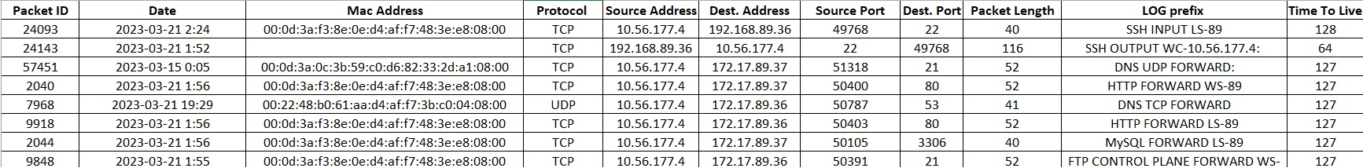

1. **What is Packet ID? Does it follow a sequence or is it random? How can you prove / demonstrate your answer?**

Packet ID distinguishes a packet from other packets and ensures that they are sent to the proper location. They appear to be in sequence which I witnessed in tcpdump.

1. **Why Windows Client Source Port is not related to the kind of service requested? Why for example SSH request is coming from a random Source Port instead of port 22? Is there any way you can fix request port number? If yes give example, if no elaborate?**

Windows Client Source Port is dynamic opposed to being static, which means it uses a random port instead of a fixed one. This can be changed by setting a specific port number in the registry.

1. **Answer previous question for DNS service? Can you explain the random Source Port issue?**

DNS service is also dynamic and would also explain why the Source Port is different.

1. **What is MAC address? Can you find the MAC addresses of your Network Interface Cards in Azure Portal? How?**

MAC address is a physical unique identifier that a network uses to identify devices. You can find the MAC address under properties in network interfaces.

